**AWeber Free | Advocate Social Media Posts and Images**

*Please use the suggested social media posts found in this document to help promote AWeber Free to your audience.*

Follow the steps below.

**Step 1:** Save these [social images](https://drive.google.com/drive/folders/1U91kESVoTDk3NHgCNPsT8yVXuOg0tuJH) to your computer.

**Step 2:** Using the social copy below, create social posts on LinkedIn, Facebook, Twitter, and/or Instagram. Make sure to add a [social image](https://drive.google.com/drive/folders/1U91kESVoTDk3NHgCNPsT8yVXuOg0tuJH) from Step 1 to your post.

**Step 3:** In your social copy, **make sure you include your unique referral link** so we can track any new accounts you send to AWeber.

**Step 4:** Add your posts about AWeber Free to your social media accounts.

# **Images**

Click an image to download it, or [go here](https://drive.google.com/drive/folders/1U91kESVoTDk3NHgCNPsT8yVXuOg0tuJH?usp=sharing).

[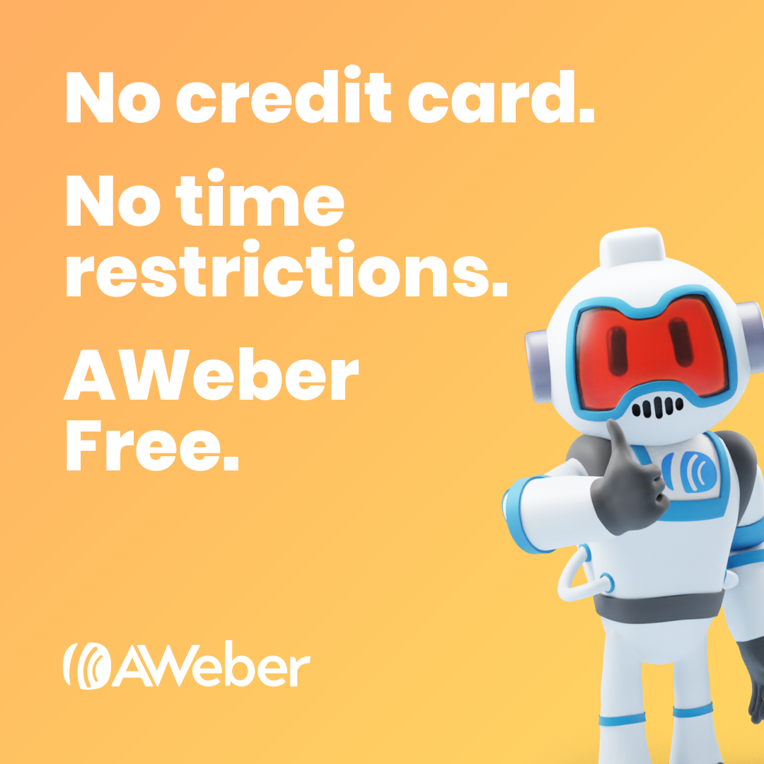](https://drive.google.com/file/d/12s2EUayGCTxGk6QAzNGpM4wK0pCCNW1l/view?usp=sharing) [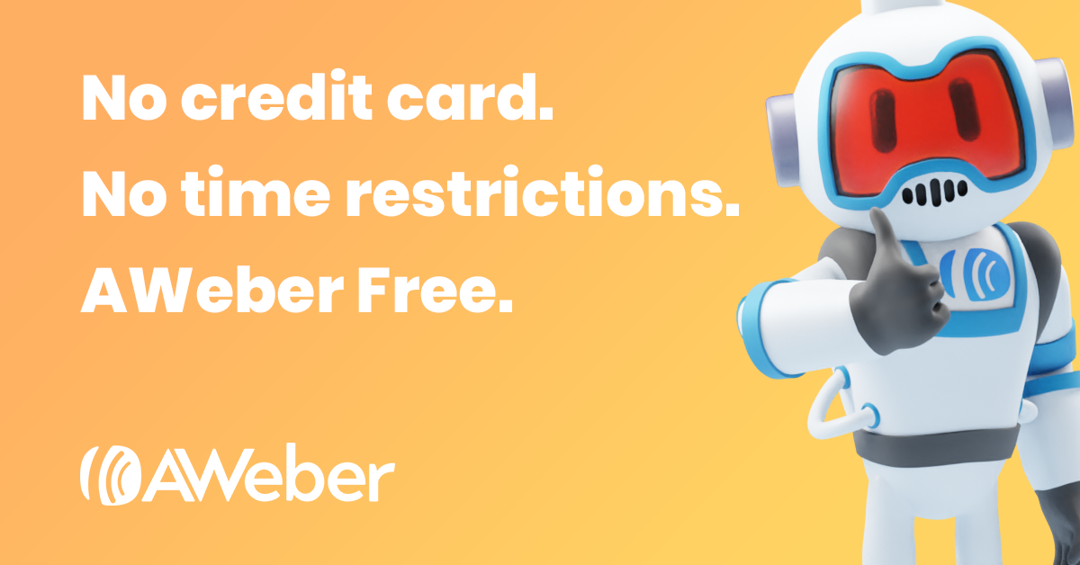](https://drive.google.com/file/d/1yQROPFMrWWX_BTT0l98jdyS-E1PHsb8T/view?usp=sharing)

[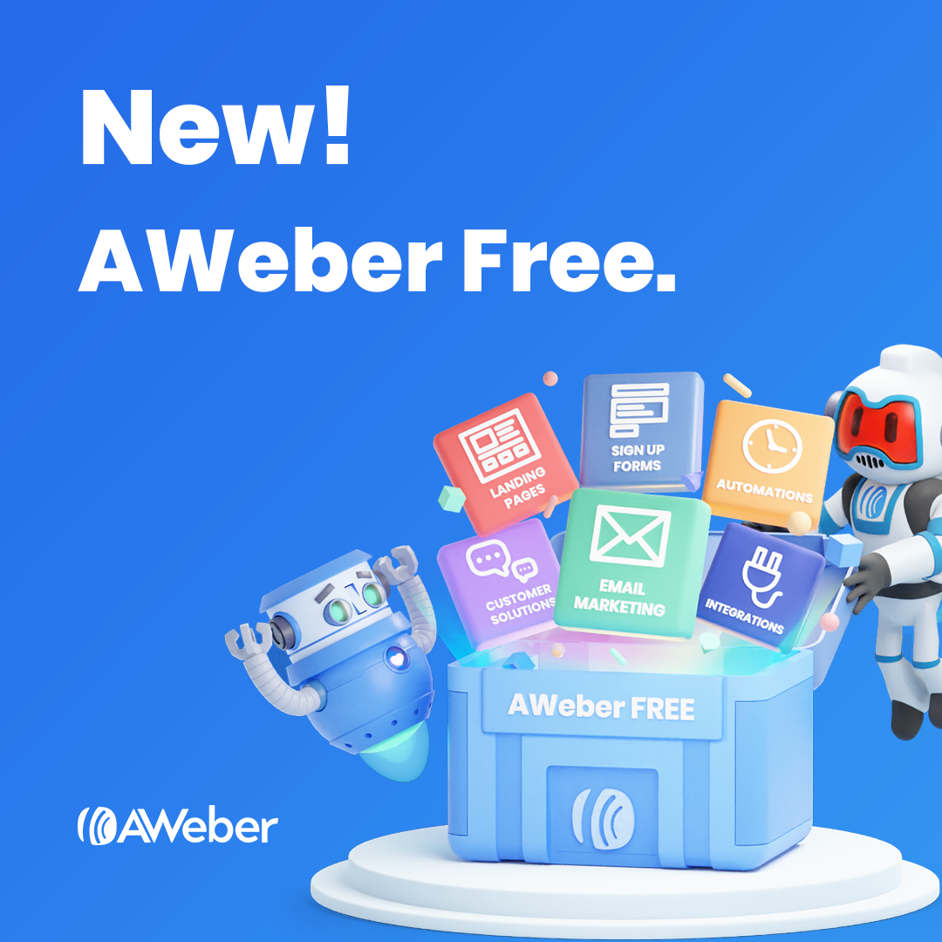](https://drive.google.com/file/d/1qS_3LvEfa8CY945MFAC9yOgmIy9E3BAq/view?usp=sharing) [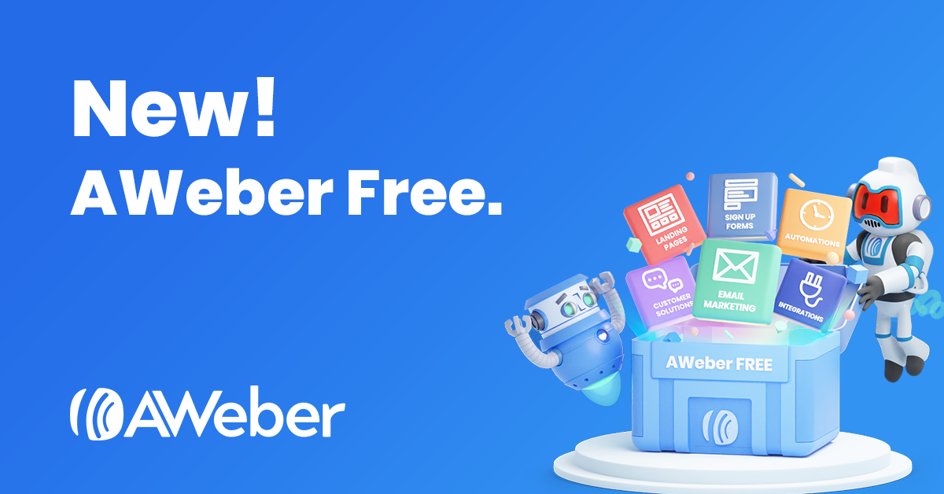](https://drive.google.com/file/d/1RQyR1KQVZ_XCQFxojP2IitM3JYgzBpqY/view?usp=sharing)

[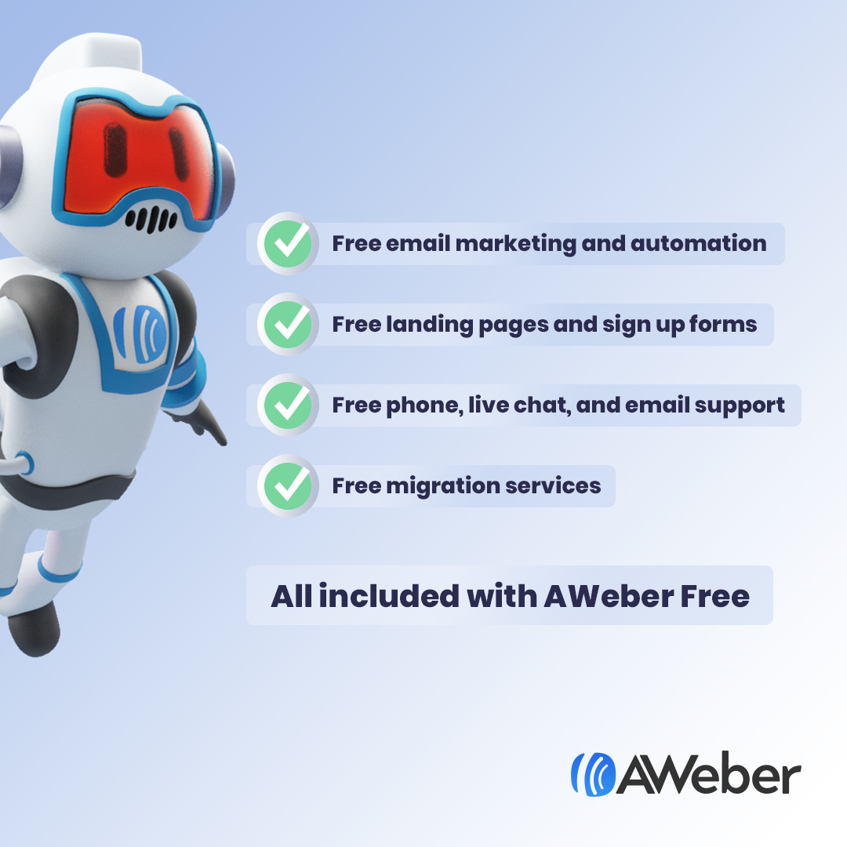](https://drive.google.com/file/d/1_uCBMZ7fbOonT5bF9c0Plw4hPSl6UQ6X/view?usp=sharing)[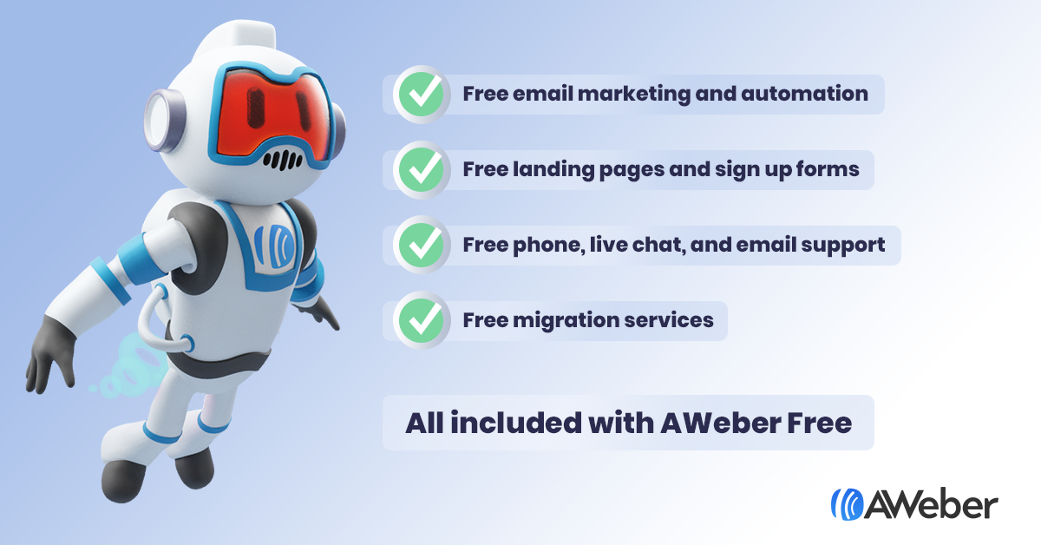](https://drive.google.com/file/d/1BY_hV0Havqa4JFJwbSyS7k3zLBNeXlpx/view?usp=sharing)

[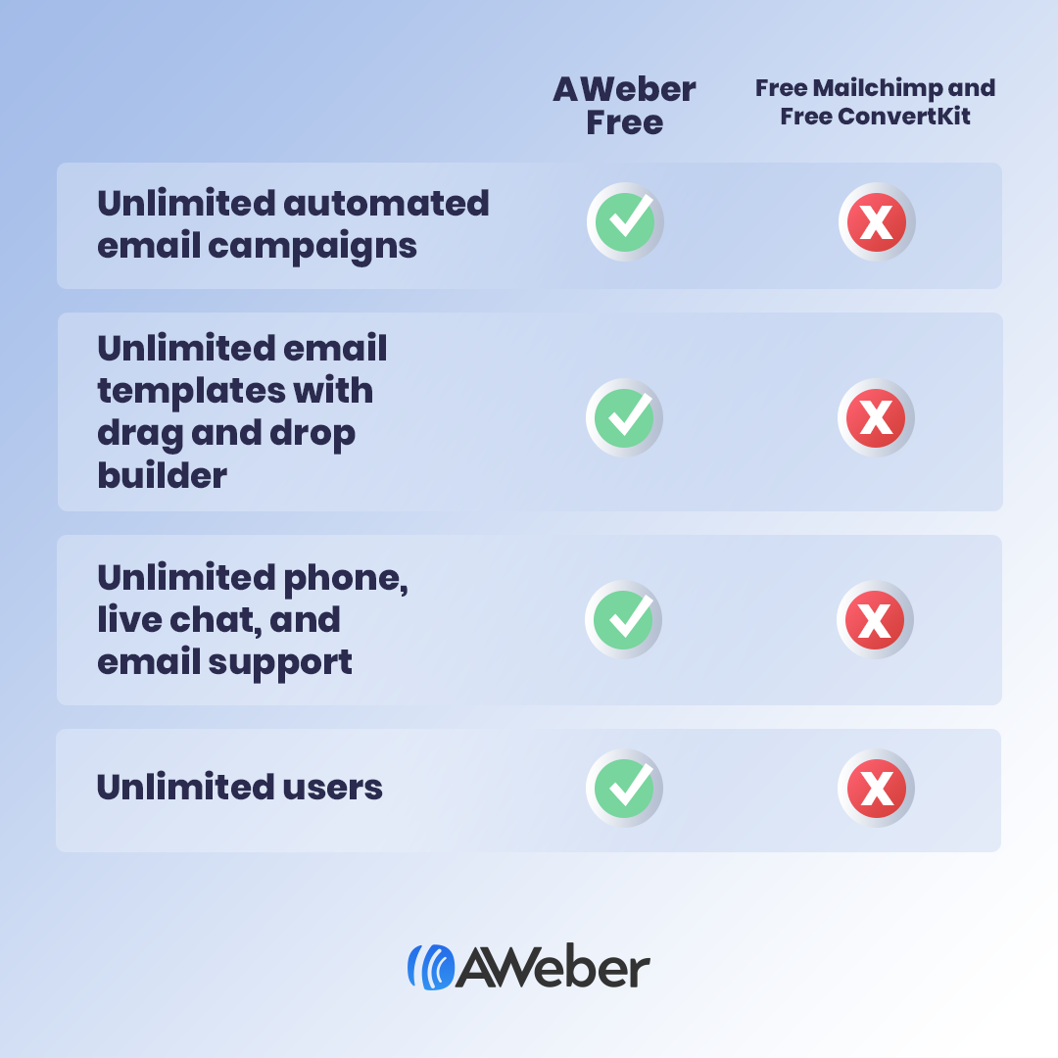](https://drive.google.com/file/d/1l-AGkWuhZMIhN2Et6U_CP1NObhDdj80E/view?usp=sharing)[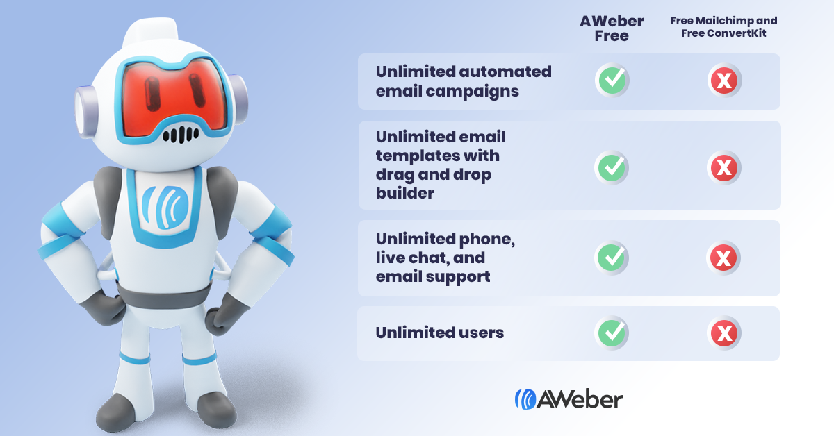](https://drive.google.com/file/d/1beRHA2gxJo--uUMBWpd0av_aQ0NHTiUH/view?usp=sharing)

[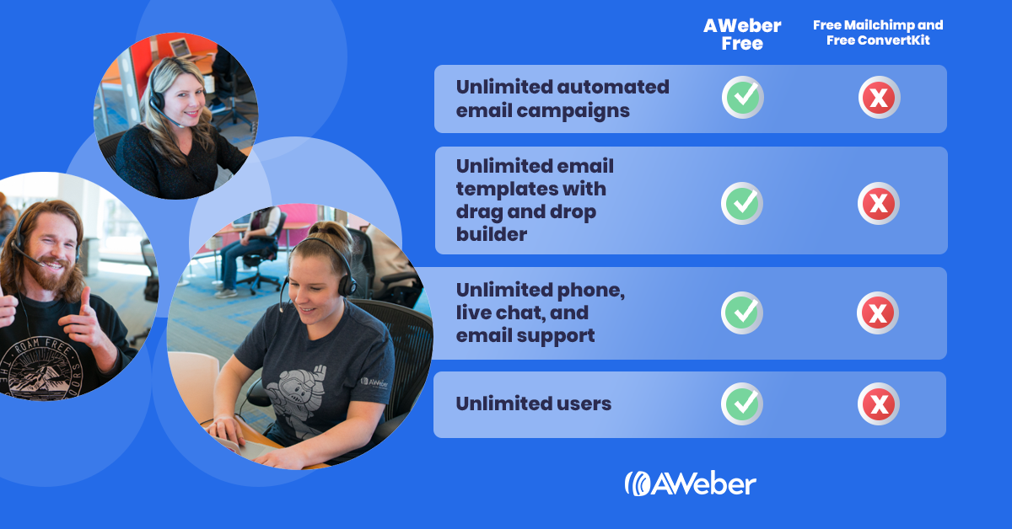](https://drive.google.com/file/d/1nOQC_ewnFNuwXCiiT48EpTTG22GGGRfo/view?usp=sharing)

# **Copy**

Copy and paste any of the following social media posts.

## Twitter:

* AWeber has added a completely free plan to its pricing! Now you can get started with @AWeber for free. No credit card. No time restriction. Create a free account today: **ENTER YOUR ADVOCATE LINK HERE**
* Just getting started with your business? @AWeber can help you grow with free email marketing. Create a free account today: **ENTER YOUR ADVOCATE LINK HERE**
* Thinking of starting a business or side hustle? @AWeber now offers a free plan to help you get started with email marketing your new venture. Create a free account today: **ENTER YOUR ADVOCATE LINK HERE**
* Now anyone can use @AWeber to build an audience and business, even if you’re just starting out and haven’t yet started earning an income. Create your free account today: **ENTER YOUR ADVOCATE LINK HERE**
* Not every business owner can invest in email marketing right away, but you still need to be able to connect with your audience. That's why @AWeber is now available to everyone. Create a free account today ⏤ no time restrictions, no credit card required: **ENTER YOUR ADVOCATE LINK HERE**

## LinkedIn:

* AWeber has added a completely free plan to its pricing. Now you can get started with AWeber for free. No credit card. No time restriction. Create a free account today: **ENTER YOUR ADVOCATE LINK HERE**
* Just getting started with your business? AWeber can help you grow with free email marketing. Create a free account today: **ENTER YOUR ADVOCATE LINK HERE**
* Thinking of starting a business or side hustle? AWeber now offers a free plan to help you get started with email marketing your new venture. Create a free account today: **ENTER YOUR ADVOCATE LINK HERE**
* Now anyone can use AWeber to build an audience and business, even if you’re just starting out and haven’t yet started earning an income. Create your free account today: **ENTER YOUR ADVOCATE LINK HERE**
* Not every small business owner can afford to invest in email marketing right away. But they still need to be able to connect with their customers and prospects. That is why AWeber is now available to everyone. Start for free and quickly grow your business ⏤ no time restrictions, no credit card required. Create your free account today: **ENTER YOUR ADVOCATE LINK HERE**

## Facebook:

* AWeber has added a completely free plan to its pricing. Now you can get started with AWeber for free. No credit card. No time restriction. Create a free account today: **ENTER YOUR ADVOCATE LINK HERE**
* Just getting started with your business? AWeber can help you grow with free email marketing. Create a free account today: **ENTER YOUR ADVOCATE LINK HERE**
* Thinking of starting a business or side hustle? AWeber now offers a free plan to help you get started with email marketing your new venture. Create a free account today: **ENTER YOUR ADVOCATE LINK HERE**
* Now anyone can use AWeber to build an audience and business, even if you’re just starting out and haven’t yet started earning an income. Create your free account today: **ENTER YOUR ADVOCATE LINK HERE**
* Not every small business owner can afford to invest in email marketing right away. But they still need to be able to connect with their customers and prospects. That is why AWeber is now available to everyone. Start for free and quickly grow your business ⏤ no time restrictions, no credit card required. Create your free account today: **ENTER YOUR ADVOCATE LINK HERE**